Required Charts
In this section, because naïve version took over 30 hours to run the 1,000,000 insertions and didn’t finish, we’ve set up a time limit to be 900 seconds. If the total running time of certain algorithm hits this limit, we will terminate such version and use 900 seconds as running time for this algorithm.
- Insert performance: naïve vs optimized
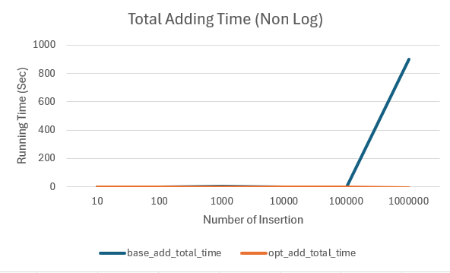
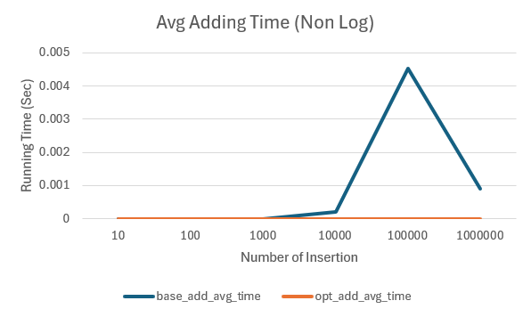
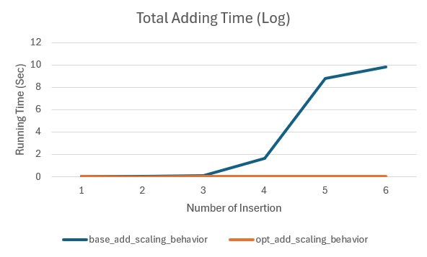
- Amend performance: naïve vs optimized
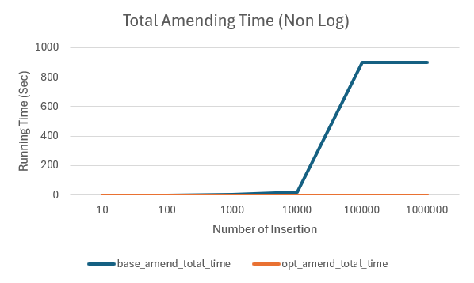
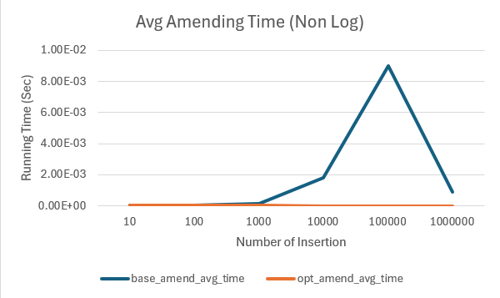
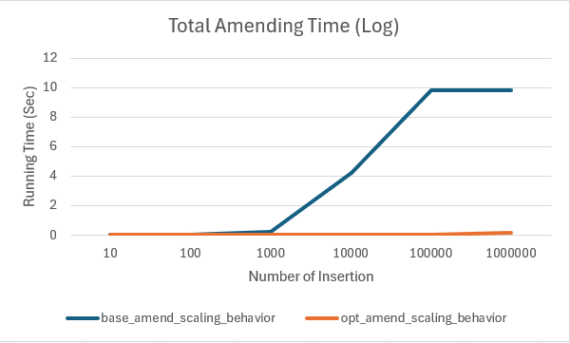
- Delete performance: naïve vs optimized
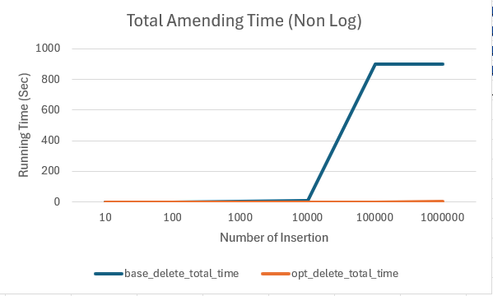
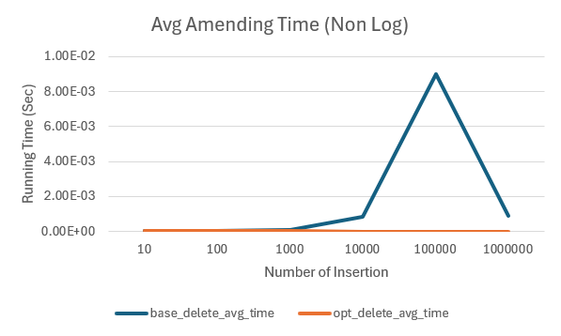
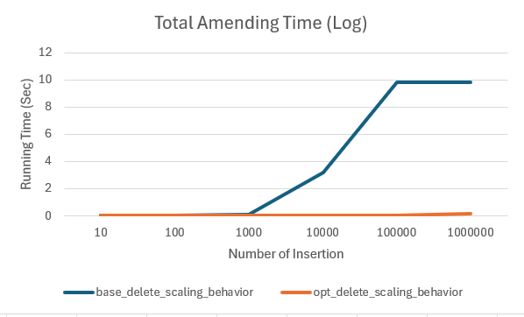
Charts must include:
- X-axis: number of operations (10 → 1 000 000)
- Y-axis: time (log scale recommended)

Required Discussion
- What data structures you chose and why
In the optimization version, we chose the data frame as structure to realize the vectorization of amending and deletion, while allowing the bulk insertion through concatenating.

- Complexity analysis of each operation
In the naïve case, the python build-in sorted() function for list takes O(n logn) time complexity using the Timsort algorithm [1].
In our optimization case,
- Adding bulk orders through pd.concat() takes 1 step and thus the complexity should be linear O(len(df1) + len(df2))
- Amending bulk orders through slicing take advantage of index and the complexity should be linear O(len(amend))
- Deleting bulk orders through pandas slicing takes advantage of index and the complexity should be linear O(len(delete))
Because we developed the heap sort algorithm for optimization sorting, there are two steps:
  - Building the heap
In this step, we take the original input dataframe and transformed into 2D array with first column equal to original dataframe index, which is the original order_id, and the second column to be target value to be sorted on.
Then, we applied heapify from the second bottom layer of the heap tree, which contains n//4 + 1 (roughly n/4) elements, with O(1) operation per parent node in this layer.
Repeatly, after correcting the heap structure for all nodes in the second bottom layer, we go up to the third bottom layer, which contains n//8 + 1 (roughly n/8) elements, with O(2) operations per node in this third bottome layer. And go all the way up to the root of the heap.
Therefore, the operation in building heap is as below

O = (n/2^2) * 1 + (n/2^3) * 2 + … (n/log2(n)) * (log2(n) – 1)

Because the height of the heap is roughly log2(n) in this binary heap, the operation ends up with (n/log2(n)) * (log2(n)-1) to heapify the root of the heap.
The total operation can be rewrite into the following format
$$O=n\sum_{i=1}^{log2\left(n\right)-1}{\frac{i}{2^(i+1)}}≤ n\sum_{i=1}^{log2\left(n\right)-1}{\frac{{1.5}^{i}}{2^{i+1}}}$$
Because the right element is a geometric series, the sum of it should be
$$S= \frac{a(1-r^{n})}{1-r}= \frac{1.5}{4}*4*(1-{0.75}^{n})$$
When n --> infinite, S = 0.5. So the original O equal to
$$O≤1.5*n$$
  - Heap sort
In the heap sort, we have mainly two steps:
    - Take out the root of the heap and append into final sorted array as output
    - Iterate through the rest of the nodes by putting each node to the root position and heapfiy the whole heap, then take out the root after heapify and repeat the next step.
Each heapify will take a maximum of O(log2(n)) complexity, which is the height of the heap, therefore the total operation complexity will be
$$O≤ n*\log_{2}^{}n$$
This is the worst case because we take out the root at each heapify, the height of the heap should, in most cases, reduce instead of remaining the same as the height of initial heap.
Therefore, our sorting operation complexity should be
$$O≤1.5*n+n*\log_{2}n$$

- Observed scaling behavior
Because we set up a time limit as 900 seconds to terminate the base algorithm, the scaled total adding, amending and deleting time for base algori thm increase with the number of operations up to 900 seconds.
The optimized version has a linear operation complexity, which make it much faster than base algorithm.

- Where the naïve version breaks down
The insertion hits the 900 seconds limit at 1,000,000 operations
The amendment hits the 900 seconds limit at 100,000 operations
The deletion hits the 900 seconds limit at 100,000 operations

- How the optimized version improves performance
Instead of inserting row by row, it takes advantage of the bulk concatenation to complete the bulk order insertion at one time.
For the amendment and deletion, it takes advantage of the index build in the dataframe and realize the bulk operation in a linear complexity manner.
In the table below, we could see the detailed running time
Table 1.
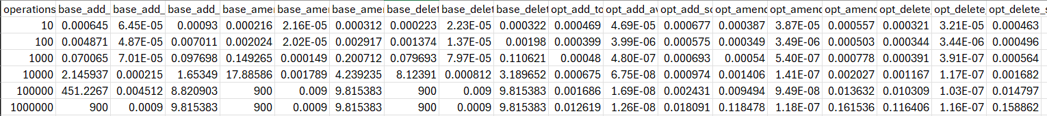
The results are also stored in PerformanceResult.csv.
As shown in Table 1, with operation number increases, the optimization version’s total adding, amending, and deletion time increases linearly, with a incremental ratio of almost 1:10, which proves the linear complexity in optimization version.

